BRADFIELD ST. GEORGE PARISH COUNCIL
MINUTES OF THE ANNUAL PARISH MEETING HELD AT THE VILLAGE HALL ON WEDNESDAY 10th MAY 2023 at 7.30pm

Present: Cllr P Squirrell (Chairman) & Mrs C Hibbert (Clerk)
SC Cllr K Soons, WS Cllr S Mildmay-White & 6 villagers (P Cllrs Croot, Stainer, Therin, Peck, Wright and Mulley).

Apologies: N/a.

MINUTES OF THE ANNUAL PARISH MEETING – 11th MAY 2022
The minutes of the last Annual Parish Meeting were circulated; acceptance was proposed by CC, seconded by GM and unanimously APPROVED as a true and accurate record and signed accordingly.

ANNUAL REPORTS
A summary of the report received from County Councillor (K Soons) is attached – a full copy is available on the Bradfield St George PC website. SC Cllr Soons highlighted; (i) the proposed new highways contract which it is hoped will provide an improved response to highway defects on behalf of SCC; and (ii) proposed improvements to SEND provision across the County. A copy of the report received from the District Councillor (Mrs S Mildmay-White) is attached to the minutes.

Village Hall – C Stainer: report received – copy attached to minutes.

ANNUAL CHARITY REPORT
Charity for Relief & Sickness Bradfield St George & Bradfield St Clare: The charity reported that it has not helped any local residents nor paid out any monies in the past year; some new committee members have been identified and discussions are ongoing as to how to move the charity forward.

FINANCIAL REPORT:
The Parish Council receipts and payments summary to 31 March 2023 was received - copy attached to minutes.

CHAIRMAN’S REPORT:
The Chairman’s report was received – copy attached to minutes.

PARISH MATTERS:
No queries were raised.

DATE OF NEXT MEETING: Wednesday 8th May 2024 at 7.30pm.

The meeting closed at 7.45p.m.

Attachments

ANNUAL REPORTS

Karen Soons SCC report Annual report - May 2023 – summary. (Full copy is available on the Bradfield St George PC website).

April 2022
£350,000 of funding to support the ambitions set out in the Suffolk Violence Against Women and Girls Strategy 2022.  Suffolk Highways will resurface 150 miles of new roads across 173 different sites across the county. | Page 4  Page 5
May 2022
Suffolk County Council has planted 198,547 trees across Suffolk in just the last two years. | Page 7
June 2022
New scheme based in Felixstowe reuses over 800,000 tonnes of water.  Funding for second phase of £45 million five-year project agreed by Cabinet. | Page 8  Page 9
July 2022
Authorities in Essex and Suffolk have united to condemn the current proposals for a 180km network of 50m tall electricity pylons.  Suffolk County Council will focus on ensuring that the county sees the maximum benefits from Sizewell C project.  A new map for hauliers plotting routes for journeys across Suffolk has been drawn up. | Page 11  Page 12  Page 13
August 2022
The council submitted a bid of £1,362,000 to the Department for Transport, as part of the Local EV Infrastructure (LEVI) pilot scheme. | Page 15
September 2022
Mobile number plate recognition system to be rolled out across Suffolk. | Page 17
October 2022
Work on a major expansion of the Foxhall Recycling Centre near Ipswich to begin.  The Council agreed a new wave of funding to provide places for children and young people with SEND. | Page 19  Page 20
November 2022
A project with the aim of replacing all 43,400 streetlights across Suffolk with sustainable, longer-lasting, and cost-saving LED bulbs nears completion.  Ground-breaking new guidelines for developers to help them design sustainable and low-carbon neighbourhoods have been launched by Suffolk County Council.  Suffolk Archives Service has received its Provisional Archive Service Accreditation from The National Archives.  A new initiative named Multiply Suffolk, which will offer adults an opportunity to improve their numeracy skills, has launched in Suffolk.  Almost £300,000 of funding has been allocated to six new projects which aim to support victims and prevent violence against Women and Girls. | Page 22  Page 23  Page 24  Page 25  Page 26
December 2022
A landmark devolution deal, which puts money and power over building, regeneration and skills into the hands of leaders in Suffolk will be signed. | Page 29
January 2023
Adult care services and children’s services will receive £47m more funding as part of Suffolk County Council’s £685m budget proposals.  Suffolk County Council has reduced its carbon emissions by 15% in the last two years. | Page 32  Page 33
February 2023
Milestone Infrastructure, part of M Group Services, has been awarded Suffolk’s new highways services contract, which will begin on 1 October 2023.  CRMP was brought to Cabinet to seek approval for its adoption from April 2023. | Page 35  Page 35

West Suffolk District Councillor Annual Report 2023

Sara Mildmay-White

Positions on West Suffolk Council
This year as part of succession planning I stood down as Deputy Leader of West Suffolk Council.
I continued with my Cabinet post as Portfolio Holder for Housing and as a substitute on Development Control and Licensing.
Chairman Barley Homes

Council tax 2023-24
Council Tax Band D
West Suffolk £ 192.06
Police and Crime Commissioner £ 262.62
Suffolk County Council £ 1,496.43

Garden Waste Collection 2023-24
Cost of Brown Bin £47.00
Link for signing up on line: www.westsuffolk.gov.uk/gardenwaste

Locality Budget Spend May 2022 – April 2023

Jubilee Celebrations at Rougham, Bradfield St George, Bradfield St Clare and Bradfield Combust with Stanningfield total of £1,850.00
Rougham Primary School swimming pool refurbishment £1,100.00
Bradfield St Clare community Kit Café £300
Total: £3,250.00

Highlights from West Suffolk 2022-23

West Suffolk Annual Report will be available at the end of May and will be circulated to Parish Councils.
Community Support. The vital work of Community Groups has always been recognised and supported by West Suffolk Council and never more so than during the pandemic. This winter £160,000 of new funding was awarded to 60 community groups and organisations helping West Suffolk residents during the winter.
£70,343.00 was also used from our Shared Prosperity Fund to support residents with the cost of living challenges during the winter.
Discretionary Housing Payment has also been available to help residents who are struggling with their rent, as well as the Local Welfare Assistance Scheme for people who are in financial hardship. www.westsuffolk.gov.uk/cost-of-living/finance-and-debt.cfm
West Suffolk Community Chest funding was increased this year to over £500,000 with the emphasis on helping residents with the cost-of-living challenges to their health and wellbeing.
Five more play areas in West Suffolk are being refurbished in a programme worth £220,000
West Suffolk was one of 4 councils and the first to go live with payments through the Energy Support Scheme Alternative Funding. This was getting funding out to residents who don’t directly pay their energy supplier and so haven’t received the payment directly from their energy supplier.
£300,000 allocated to ensure swimming pools could stay open in West Suffolk despite soaring energy costs.
Together with partners West Suffolk Council are collectively investing £500,000 to help reduce council tax by 100% for a year for means tested low-income families. Around 11% of households under this initiative and others will pay no or reduced council tax.
Suffolk’s District and Borough Councils have secured £2.2 million of Government funding to improve the standard of private rented homes in the county, tackling poor housing conditions and improving tenants’ wellbeing.
Continuing the investment of £9 million in initiatives to tackle the climate crisis and reach net zero by 2023.
Planned balanced budget helping to deliver a £40 million replacement for Bury St Edmunds leisure centre as part of the first phase of the Western Way development.
Nearly £28 million investment of capital expenditure identified to spend over the next 2 years on economic growth and prosperity including the Incubation Units on Suffolk Business Park.
£440,000 for car park improvements including the provision of electric charging points across West Suffolk.
Work completed on the £8.4 million scheme to redevelop the Post Office building in Bury St Edmunds, retaining the historic Victorian façade and widening the link between marketplace and the Arc. This work provided 2 retail units together with 12 apartments which have now been sold.
Development of the new car park on the north side of Bury St Edmunds railway station and new entrance to the station on the northside, 75 additional cycle parking places.

Continued investment in solar energy ,working with businesses to put solar power on their properties as well as the council’s own, which will see an additional £1.75 million in solar income for the council as well as generating electricity to supply the council’s buildings.
Barley Homes the Council’s wholly owned housing company has delivered developments in Haverhill whilst providing an income to the Council.
Homelessness work and support for refugees and asylum seekers has been at the forefront of work this year. Rough Sleeper numbers have been reduced from a high of 36 in 2018 to 9 in 2022. These numbers fluctuate and a number of these clients have been housed on several occasions but for a variety of reasons are unable to sustain a tenancy despite support and we do continue to work with them.
We continue to meet the governments housing targets with1003 dwellings completed across West Suffolk in 2022/23. This has outperformed our government target of 806 and includes meeting our council target of 30% affordable homes.
A major planning application by West Suffolk Hospital for a new health campus/hospital was approved by development control committee and I look forward to that development moving forward.
Finally, many hours have been spent working on the new West Suffolk Local Plan. This is a government requirement and all councils should have one in place by 2024. The local plan provides a vision for the growth and development of an area together with policies which set out the way that the council aims to meet the housing, employment, social and community needs of their area, at the same time as protecting and enhancing the natural, and historic environment. Further consultation on the local plan will come forward in 2023.

Thank you all for your continued support, it is a great pleasure and honour to represent our lovely villages.
Finally, a thank you to all the parish councillors and volunteers who work so hard to keep your village vibrant and attractive.

Sara Mildmay-White

Bradfield St George Village Hall Management Committee - Chair’s Report to the PC for 2022

The village hall is now back up to pre covid usage and possibly has even surpassed it. Bradfield Nights are regularly very well attended and hot food is enjoyed by many who attend. The kitchen received a 5-star environmental rating at the end of the year.
In spite of bad weather, a successful afternoon tea event was held in June to celebrate the now late Queen’s Platinum Jubilee. This included a BBQ, bar, afternoon tea, a bouncy castle and live streaming of events in London. This event was generously supported by our 2 local councillors.
August saw the return of the beer festival with live music. This event was a great success helped by the lovely weather and the Felsham based band Twelfth Night. A selection of beers and ciders was also enjoyed by the many who attended as well as the BBQ serving pulled pork as well as burgers and sausages. There was a bouncy castle and face painting for children.
In November the Firework Night event was again a success with a BBQ and a bar. The committee had devised a new queuing system for the BBQ which was a great improvement on previous years and kept queuing to a minimum.
Quiz Nights have continued throughout the year with attendance numbers fluctuating from 3 to 10 teams and often a pizza van in attendance which is open to all, not just quizzers.
Live streaming of International Rugby matches continues to be popular.
There is now 1 regular booking for a Yoga class on a Tuesday night.
The hall is cleaned regularly, and repairs and maintenance are carried out by members of the committee or professionals as appropriate.
The lights are due to be replaced by energy efficient LEDs and the committee are currently looking into having the bar refurbished.

Christine Stainer
May 2023

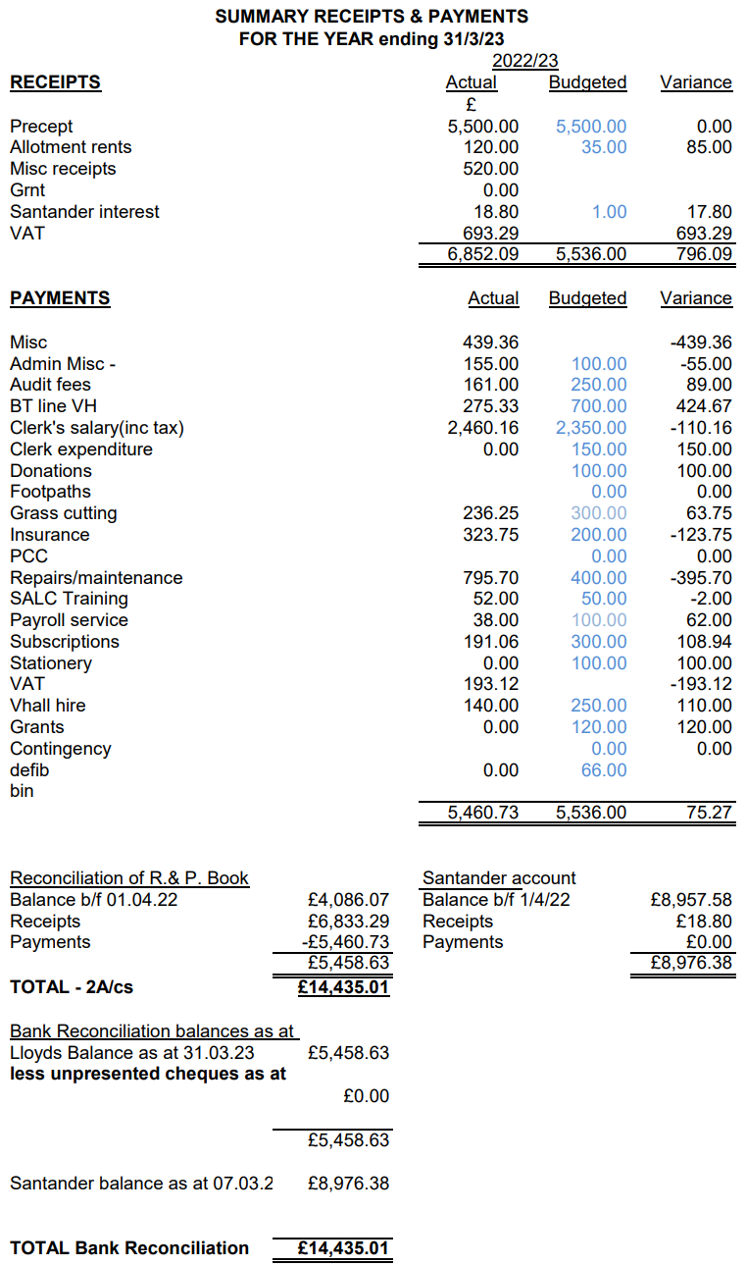

Bradfield St George Annual Parish Meeting - Chairmans’ Report 2023.
The Parish Council remains at full strength after the recent elections , all Councillors to continue for another term.
The Allotments are getting almost to capacity with the Monkey Workshops expanding their area , willing to utilise some of the more unsuitable ground. Due to the demand and also a potential donation, the Parish Council are assessing the potential to put a water supply for the allotment holders. It will mean a sizeable increase in rent fees to cover the water useage charges.
This has gone out to consultation to the current allotment holders to see if the majority are happy.
The old telephone kiosk renovation was eventually completed with the addition of new shelving and once again proving popular as a book library.
With the pressure on everyone’s finances the Parish Council decided not to increase precept for the current year as we have good financial reserves.
Planning applications continue to be made, so I assume that means Bradfield St George remains a popular place to be. Though we do have to try and protect our open views .
May I thank our County Councillor Karen Soons, and our Borough Councillor Sara Mildmay-White for their continued support, along with all the other Councillors on this Parish Council.
I also wish to thank Catherine our Clerk for keeping our paperwork and finances all in order.
Cllr Peter Squirrell - Chairman.

