BRADFIELD ST. GEORGE PARISH COUNCIL MEETING HELD
AT BRADFIELD ST GEORGE VILLAGE HALL ON WEDNESDAY 10th JULY 2024

Present: Cllrs P Squirrell (Chairman), C Stainer, C Croot, A Therin, T Wright & J Peck.
C Hibbert (clerk). WSC Cllr S Mildmay-White.
No members of the public.

The meeting opened at 7.30pm

1. APOLOGIES AND APPLICATIONS FOR APPROVAL OF APOLOGIES
P Cllr G Mulley and SC Cllr K Soons.
2. PUBLIC FORUM
N/a.
3. INTERESTS
3.1 To receive Councillors’ Declarations of Interest on any item in the agenda; CS and CC declared an interest in items 5.3 and 8.3 as Trustees of the VHMC. PS declared an interest in item 8.3 (payments). PS and AT declared an interest in item 6.2 as personal acquaintances of the applicant for planning permission.
3.2 To consider any applications for dispensations. No dispensation applications were received.
4. MINUTES OF THE PARISH COUNCIL MEETING DATED 8th MAY 2024. The minutes of the Council meeting held on 8th May 2024 were UNANIMOUSLY APPROVED and signed as a true and accurate record.
5. REPORTS
5.1 Suffolk County Council report. In the absence of SC Cllr Soons, her report was received and will be uploaded onto website.
5.2 West Suffolk Council report. WS Cllr Mildmay-White delivered a verbal report which covered recent national elections and refurbishment plans for the leisure centre.
5.3 Village Hall report. The Chairman of the VHMC agreed to circulate a copy of her report after the meeting.
6. PLANNING AND APPEALS
6.1 To receive planning notifications. None received.
6.2 To consider DC/24/0743/VAR Planning application - removal of condition 8 of E/89/1190/P relating to agricultural occupancy Keats Farmhouse Church Road Bradfield St George Suffolk. The meeting considered this application and in particular; (i) whether the property is currently occupied by a person involved in agriculture; (ii) the purpose of agricultural occupancy conditions; (iii) whether there was a need for an agriculture tie on this particular property. AT and PS abstained from voting due to their personal acquaintance with the applicant. CC chaired the vote on this item. No objection (2 votes); No comment (2 votes). It was AGREED to submit ‘No comment’ (Vice Chair’s casting vote).
7. TO CONSIDER
7.1 Review and approve finance regulation orders based on new model template; Reviewed and APPROVED.
7.2 Allotments The meeting received correspondence highlighting that the communal areas (usually maintained by the allotment holders themselves) have not been cut this year and are overgrown. It was AGREED that the current contractor for the green would cut what he could access (budget of up no more than £300 agreed) and that consideration would be given to including this item of work in the spec for 2025.
8. FINANCES
8.1 To receive and approve the financial summary to 30 June 2024); reviewed and APPROVED.
8.2 To receive and approve the bi-monthly financial summary for May-June 24; received and APPROVED.
8.3 To approve payments to be issued; the following online payments were APPROVED..
Detail | Cheque no/online authorisation | Payment | Net | VAT | Gross
1. | BT | DD - TBC | 26.71 | 5.34 | 32.05
2. | BT | DD -TBC | 26.71 | 5.34 | 32.05
3. | SALC - audit | online | 177.00 | 35.40 | 212.40
4. | CH wage | online | 521.60 |  | 521.60
5. | HMRC wage | online | 117.20 |  | 117.20
6. | VHMC | online | 20.00 |  | 20.00
7. | JH Squirrell & Sons – grass cut | online | 192.00 | 38.40 | 230.40
8.4 To receive BSG internal audit report for 23 -24 and to approve any consequent actions including amendment to approved accounting statement for 23/24. Received and recommendations NOTED and APPROVED, including an adjustment to staff and other costs on the accounting statement in the AGAR for 23 24.
9. CORRESPONDENCE AND CIRCULARS The following correspondence was received and NOTED;-
9.1 SALC e bulletins June/July;
9.2 Information on Changes to Community Chest funding;
9.3 Information on Thriving Communities Fund
9.4 SALC West Suffolk invitation - drop in session for SALC Constitution & speaker on Local Nature Recovery Strategy;
9.5 campaign information on safety of Lithium ion Batteries and e-bikes and scooters
9.6 Update from SALC on changes to legislation regarding funding of churchyard maintenance.
10. DATE OF NEXT MEETING
The date of the next meeting is Wednesday 11th September 2024 at 7.30pm.

The meeting closed at 8.40pm.
[Apologies received from TW for Sept 2024 meeting]

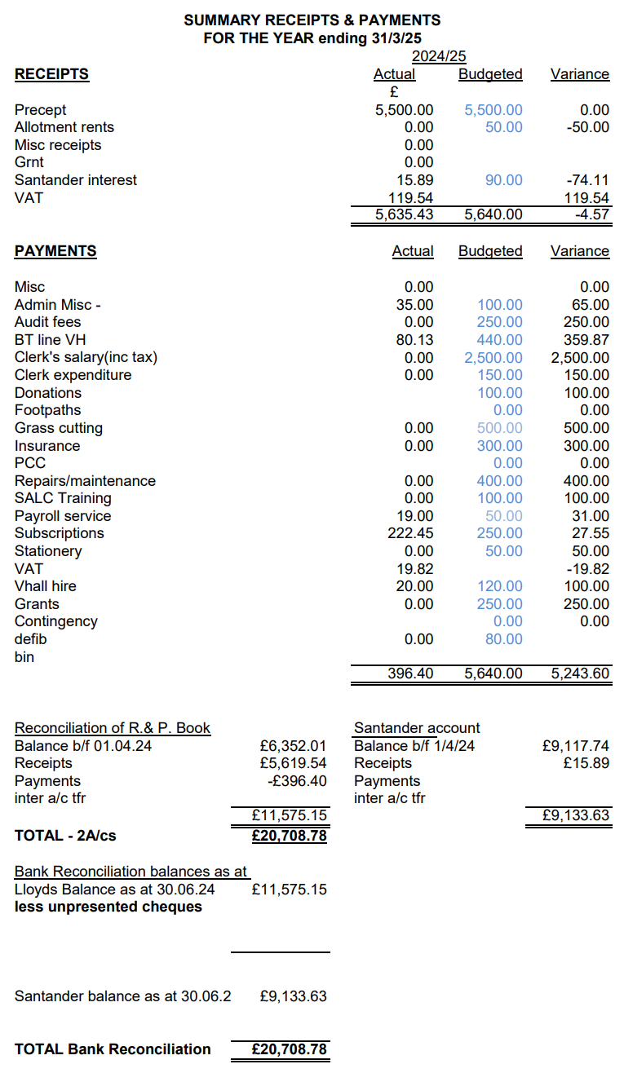
Attachment to item 8.1

